**Popularity vs Critical Appeal: An Analysis of Metacritic reviews.**

For an upcoming project, I had to compare Metacritic’s ‘Meta-score’ (aka the ‘critic score’) and ‘User-score’. Since the review website ‘metacritic’ has two types of reviews, I wanted to know if they would give similar results. The Meta-score is an aggregate of reviews from critics. A single number out of 100 meant to show the opinions of many different critics. By contrast, the User-score is like the ‘popular vote’ on the website. Users are allowed to rate a piece of media out of 10, and the number shown on the website is an average of those many ratings.

The data is for video game reviews, and each point presents the final score given for a game.

It turns out, they are similar, but less than you might think.

Statisticians and Data-nerds can note that the correlation had a strength of 0.536, and a p-value of <0.05

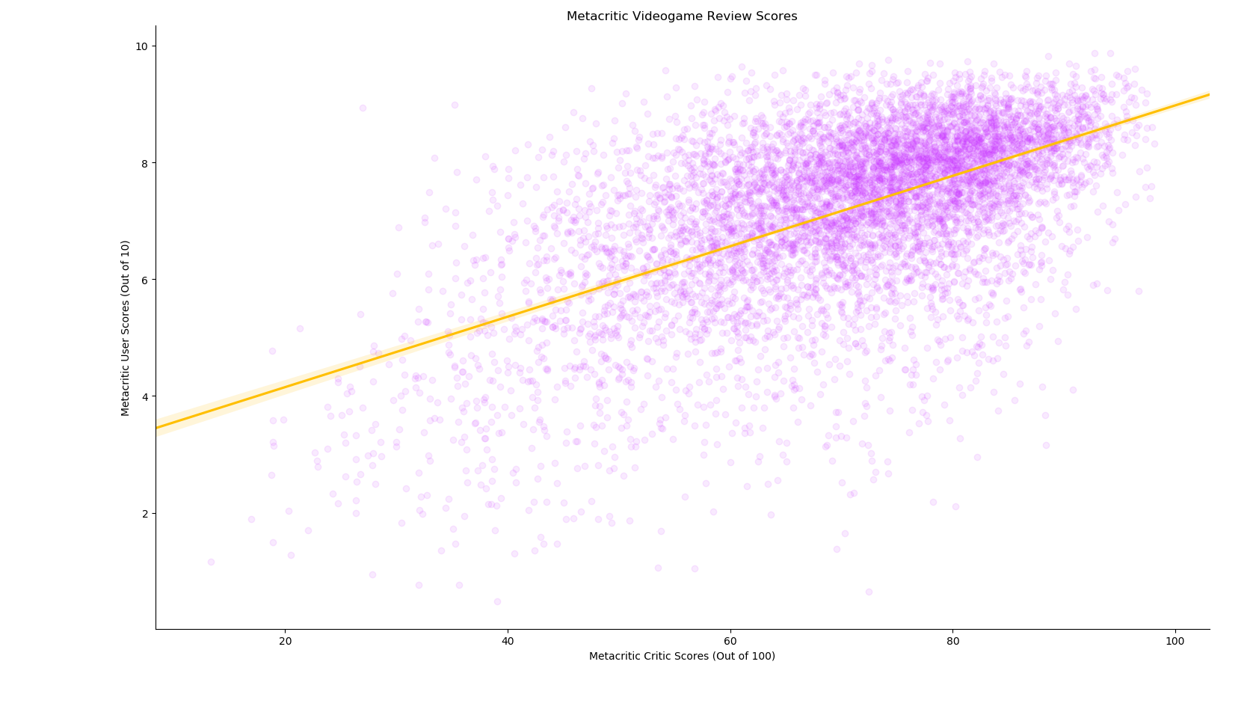

**Results:**

Meta-critic Metascore & User Scores have a moderate positive correlation to one another. These results are statistically significant.

To simplify that statement: The relationship between Meta-scores and User-scores generally line up. Most of the time, critic and user scores are pretty close to one other. When one group gives a high score to a game, generally so does the other. Likewise with low scores, or scores that fall somewhere in the middle.

Because this is only ‘moderately’ correlated, there are still a lot of times when the two scores differ. The little dots that are further away from the main “swarm” are ones where one score is vastly different than the other.

With the number of reviews used in this analysis, it’s unlikely that the similarities between the two datasets are a coincidence.

You may notice that Critic scores are out of 100, while User scores are only out of 10. Aside from giving a little less ‘wiggle room’ for users, this doesn’t affect the analysis too heavily. Users can only rate something out of 10, but the overall rating on a videogame can still have a decimal point in it (i.e. 8.7/10)

**Interpretation:**

Even beyond looking at a specific genre, most users develop a ‘taste’ for certain games, based on franchises and game studios. Gamers learn what games they enjoy, and what games to avoid. Critics often lack that freedom, and may be circumstantially forced to play games they may have a negative predisposition towards, or would otherwise not consider better than “middle of the road”.

Critics may have to “take one for the team” and review the occasional game they know is going to be awful. Users just know to avoid them.

Another possible explanation is simply that critics score lower because they are…critics. Their goal is to accurately assess the quality of a game as best as possible.

Theories aside, the results of this correlation told me what I needed to know. ‘Meta-scores’ and ‘User-scores’ are similar- but different enough that I can include both in my next analysis.